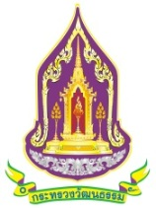
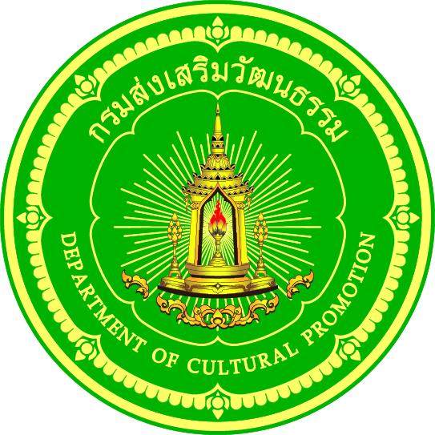
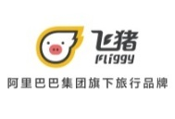
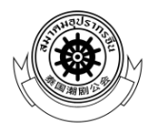

‘THE ICONSIAM ETERNAL PROSPERITY CHINESE NEW YEAR 2019’
The Riverside Extravaganza Celebrating Chinese New Year
Featuring Thailand’s Longest LED-Illuminated Dragon, Lion Dance
And Incredible Performances from China
February 2 – 5, 2019 at ICONSIAM
ICONSIAM, the spectacular Bht 54-billion landmark development and iconic landmark of Thailand’s eternal prosperity on the Chao Phraya River, in partnership with Ministry of Culture, Department of Cultural Promotion, True Corporation Co., Ltd., CITIBANK, China’s leading online tourism platform Fliggy, and the Chinese Opera Troupe have joined forces to bring an exceptionally auspicious event of the Pig Year to life in ‘THE ICONSIAM ETERNAL PROSPERITY CHINESE NEW YEAR 2019’. The event is set to feature a lineup of magnificent shows, including splendid performances from award winning China’s top acrobatic troupe, Thailand’s longest LED-illuminated golden dragon from Chinese folklore stretching to an impressive length of 108m from 2016’s Asia competition winner and Chinese lion dance performance from 2018’s Asia award winner, as well as live Chinese Opera performances from the Ministry of Culture, along with multiple workshops and activities between February 2 – 5, 2019, at ICONSIAM, on Charoen Nakhon Road.

ICONSIAM Managing Director Supoj Chaiwatsirikul spoke about the upcoming event, “Chinese New Year is one of the most important events for Thai-Chinese communities in Thailand as it is a period of appreciating and preserving our rich heritage, and an excellent period to promote our outstanding tourism reputation. Therefore, ICONSIAM, with our official partner, the Ministry of Culture, are hosting ‘THE ICONSIAM ETERNAL PROSPERITY CHINESE NEW YEAR 2019’ to proudly exhibit and preserve our Thai-Chinese culture and heritage. The area we are situated in, Thonburi, by the Chao Phraya River, has a rich history — specifically the Klong San – Ta Din Daeng neighborhood, where lots of Thai-Chinese communities live in harmony. Moreover, it is an area that continuously draws international tourists to visit — highlighting its reputation as one of the world’s most popular destinations with special emphasis on being ‘the world’s first’ and ‘Thailand’s first’, where ICONSIAM is situated. The special event is set to take place between February 2 – 5, 2019. We are honored to welcome the Minister of Culture, Vira Rojpojchanara in the commencement ceremony on February 4, 2019 (16.30 hrs). In addition, the event will feature a live performance from Thailand’s leading actor James Ma, who will take part in the Chinese lion dance performance bringing auspicious fortune to the audience, and famous actress Kimberley Anne Woltemas who will be bestowing luck and blessing at ICONSIAM’s riverside ‘River Park’ plaza.

ICONSIAM Managing Director continued, “For this unique occasion, ICONSIAM is going above and beyond by bringing in China’s leading acrobatic troupe, from Hunan province, who has won multiple awards domestically and internationally. Their series of award winning acts includes extreme gymnastics, which had earned them a gymnastics award in youth category in New Zealand in 2018, girl’s power tumbling, which their members obtained winner medals in youth category in New Zealand in 2018, aerial acrobatics, and much more.

However, the central act focuses on the majestic show of Thailand’s longest LED-powered golden dragon — at 108m in length, where it will sprinkle blessed water to nearby viewers, along with the grand dragon and 9 mighty lions before unveiling Chinese banner scrolls. These acts will be performed by winners of 2016’s Asia awards. The act of 9 mighty lions, illuminated by LED lights, involves the competition to obtain a magical orb. In addition, the act of the grand lion carrying the plum blossom will be performed by winners of 2018’s Asia awards. Guests can also indulge in the traditional Chinese opera, which has become a rare form of entertainment today — courtesy of the Ministry of Culture, where they would provide facts and knowledge about the traditional Chinese opera, spreading Chinese heritage and values through their curated exhibition. Lastly, workshops and activities such as face painting in Chinese opera style will be available for guests to capture truly incredible experiences.”

At Charoen Nakhon Hall, M Floor, visitors can view and participate in Chinese-oriented activities for 4 consecutive days, including acrobatic shows, Chinese calligraphy and Chinese knotting workshops, live music shows performed with traditional Chinese instruments, traditional Chinese opera, reading zodiac signs, live talk shows based on auspicious values, and shopping for auspicious items, imported directly from China. Furthermore, witness ICONSIAM’s unique, contemporary golden Chinese pavilions where visitors can relax at, surrounded by an eclectic mix of Chinese tiaras, and majestic peony flowers, which symbolize good fortune, wealth, and loyalty. River Park plaza and the peony tunnel, located near ICONLUXE, can be seen with a luxurious decoration of glowing lights. Visitors are free to experience the opulent settings and snap pictures of the Chinese décor until February 28, 2019.
Visitors at ICONSIAM can expect a variety of exclusive promotions: with a minimum purchase of THB1,000, shoppers are eligible to participate in prosperity-enhancing activities such as reading zodiac signs, Chinese lottery poetry, and the auspicious windmill. Make a minimum purchase of THB2,000 to receive an entry to win 10 Baht gold bar (3 prizes), or 1 Baht gold pig-shaped pendant (20 prizes) — with a total worth of THB1 Million. In addition, shoppers can expect special sales promotion, up to 30% at Siam Takashimaya department store. Extra special privileges for VIZ Card holders: 1st step by simply making a minimum purchase of THB15,000 to receive OneSiam Gift Card valued at THB200, a minimum purchase of THB40,000 to receive OneSiam Gift Card valued at THB700, and a minimum purchase of THB100,000 to receive OneSiam Gift Card valued at THB2,000; 2nd step for the first 50 top spenders are entitled to receive up to 200,000 bonus points (conditions apply) — between January 31 – February 17, 2019.

Experience the extravaganza of ‘THE ICONSIAM ETERNAL PROSPERITY CHINESE NEW YEAR 2019’ and celebrate the auspicious Year of the Pig between February 2 – 5, 2019, at ICONSIAM, on Charoen Nakhon Road. For more information, call 02-495-7080, or visit www.iconsiam.com

For further information, please contact Public Relations Department of ICONSIAM. Tel.0-2495,7000 # 7358
Jiraporn Viriyaphisathan (Heang) 089-699-9322 jiraporn.v@supremo.co.th
Arisara Thanuplang (G – Jap) 081-561-4745 arisara.t@iconsiam.com
Sireetorn Niyomsen (Koy) 081-8311406

